**Customer Management System**

**UML Class Diagram**

Kehsin Yu | NUID: 002747728 | Section 08

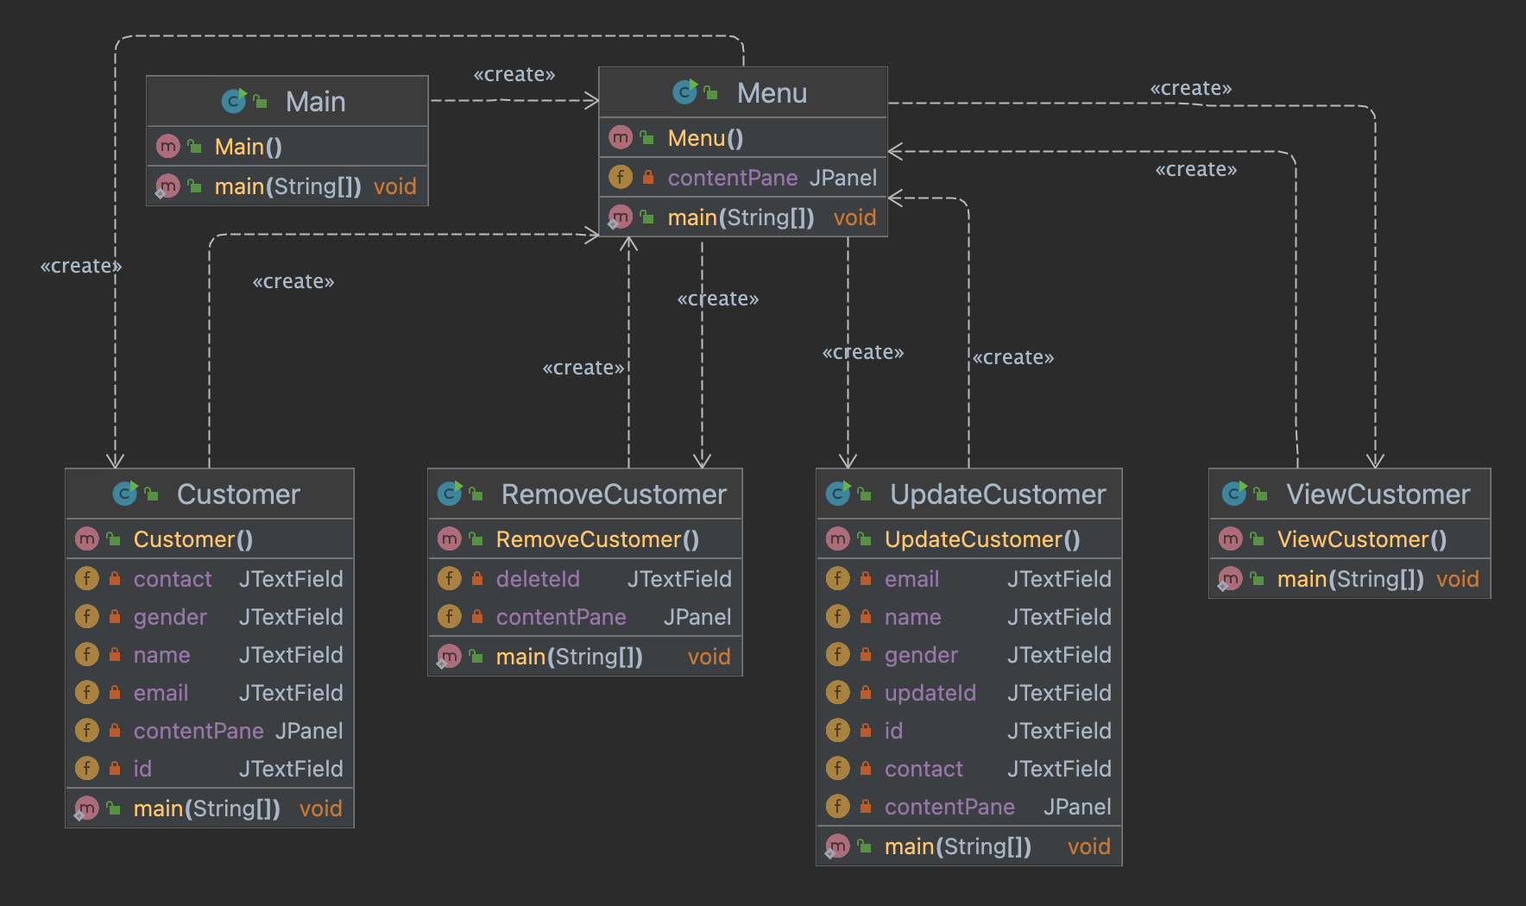

The Customer Management System application is used to manage the customer data for companies.

* ***Class***

1. Main class is used to run this application.
2. Menu class is used to show all the functions for user to choose from.
3. Customer class is used to store a customer’s information.
4. RemoveCustomer class is used to remove information of a targeted customer.
5. UpdateCustomer class is used to update information of a targeted customer.
6. ViewCustomer class is used to show all the customer data in this management system

* ***Attributes (Field)***

Menu

1. contentPane: the design panel of the menu

Customer

1. contact: customer’s contact phone number
2. gender: customer’s gender
3. name: customer’s name
4. email: customer’s email
5. contentPane: the design panel of add a customer
6. id: customer’s id

RemoveCustomer

1. deleteId: the customer id that is intended to delete
2. contentPane: the design panel of delete a customer

UpdateCustomer

1. email: updated customer email
2. name: updated customer name
3. gender: updated customer gender
4. updateId: the customer id that is intended to update
5. id: updated customer id
6. contact: updated customer contact phone number
7. contentPane: the design panel of update a customer

* ***Method***

Main

1. main(String[]): the main method for running the Customer Management System application

Menu

1. main(String[]): the main method for running the menu
2. Menu(): the setting and layout of the menu

Customer

1. main(String[]): the main method for adding a customer
2. Customer(): the setting and layout of adding a customer

RemoveCustomer

1. main(String[]): the main method for removing a customer
2. RemoveCustomer(): the setting and layout of removing a customer

UpdateCustomer

1. main(String[]): the main method for updating a customer
2. UpdateCustomer(): the setting and layout of updating a customer

ViewCustomer

1. main(String[]): the main method for viewing a customer
2. ViewCustomer(): the setting and layout of viewing a customer